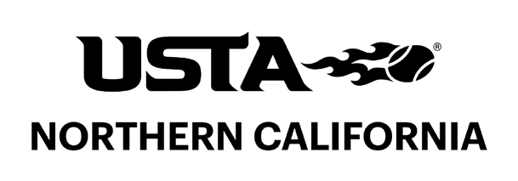
Minutes of the USTA NorCal Constitution & Rules
PENDING COMMITTEE APPROVAL
Committee Meeting - Monday, July 7, 2025

NOTE: These minutes were approved by Committee on August 4, 2025.

Jason Scalese, chair of the Constitution & Rules Committee, called the meeting to order at 7:30 pm and roll call was conducted. The meeting was held in the NorCal office in Alameda.

Committee Members Present: Jason Scalese (chair), Leslie Airola-Murveit, Andrea Norman, Linda Peltz, Jon Toney, Keith Wheeler

Committee Members Absent: Scott Winn

USTA NorCal Staff Present: Summer Verhoeven - Executive Director

1. Approval of Minutes. The Committee considered approval of the minutes of the meeting held March 17, 2025. The following motion was duly made by Leslie Airola-Murveit, seconded by Jon Toney, and approved by a vote of 5 in favor, none opposed, and no abstentions:

RESOLVED: That the minutes of the Constitution & Rules Committee meeting held March 7, 2025, be approved as corrected.

Keith Wheeler joined the meeting following the approval of the minutes.

2. Review of Bylaws. The Committee met to review the draft of Restated Bylaws prepared by nonprofit legal counsel. The members also created a list of questions about existing provisions.

Following conclusion of business, the meeting was adjourned at 8:40 pm.

