**Ice Machine**

**Temporarily Unavailable**

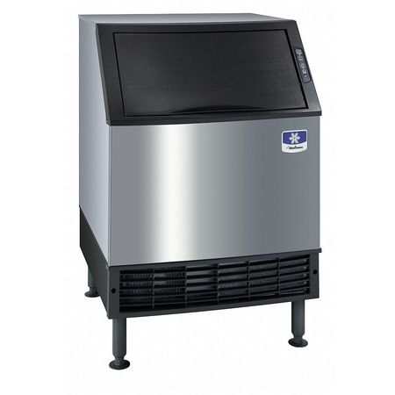

**[ Add your facility/contact information, any required City information, and/or USTAFlorida.com/coronavirus** **]**