**Please bring your own:**

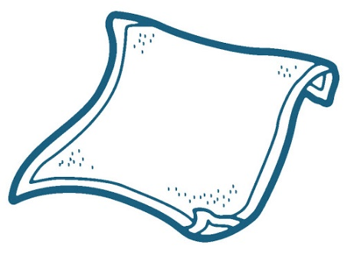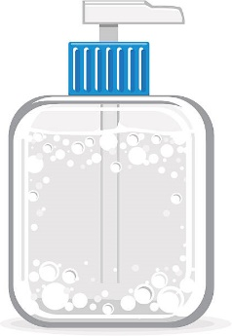

**Hand Sanitizer**

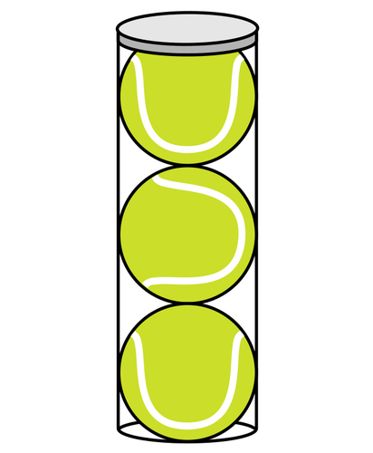

**[ Add your facility/contact information, any required City information, and/or USTAFlorida.com/coronavirus** **]**

**Towel**

**Wipes**

**Balls**

**Water**