**Limited Facility Seating**

**Please bring your own portable chair**

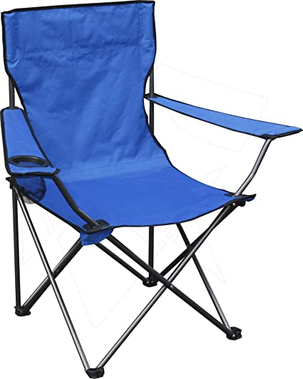

**[ Add your facility/contact information, any required City information, and/or USTAFlorida.com/coronavirus** **]**